January 17th, 2010
Hi

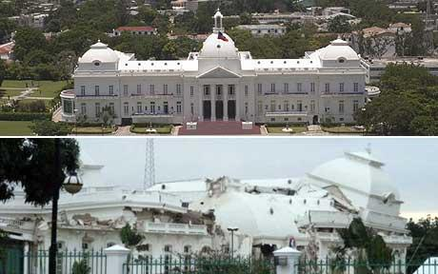
The big news of the week is the terrible earthquake in Haiti (pic shows what happened to the Presidential palace). It appears to be far worse than those in Padang, Indonesia recently, and in China last year. I sent in a donation to Medicines Sans Frontiers (which is called by its English translation in the US as ‘Doctors without Borders’). I did this online which is very convenient though there are other more traditional ways to do this. For the Padang earthquake, I donated through World Vision but by cheque, which is a bit more troublesome, as I did not realise until yesterday that it could also have been done online. I will donate to these organisations; they can be trusted as they handle things themselves. I would never donate through a government who usually just pass the money to governments or other agencies, many of whom may be corrupt. This is what happened to some of the money the HK Government donated to the Sichuan government for its earthquake relief. (For the Haitian earthquake, the HK government does not seem to have donated a cent, yet they gave HK$10 billion to Sichuan for earthquake relief – one can make one’s own inferences as to why!) I also saw on the news that US marines from Camp Lejeune have been sent to Haiti on board the USS Bataan, having just returned from ‘float’ a few weeks ago. Gavin – was the Bataan the vessel you did your floats on?

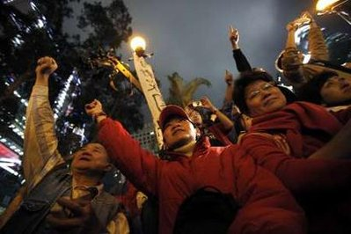


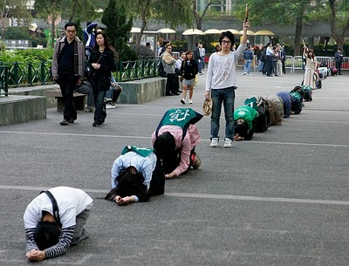
Quite a lot of things have happened in HK in the past few days. Remember that a year or so ago there was a collision between a Ukrainian floating crane boat and a Chinese container ship in which the Ukrainian vessel sand with the loss of 18 lives? Well, the people involved in the collision received jail sentences. The acid attack suspect apprehended last week turned out not to be the culprit, but was in fact wanted for some other crime. However, the police did arrest the person involved in the Causeway Bay acid attack a month or so ago. I think I mentioned last week that there have been four acid attacks recently; in fact, the number for the past year seems to be about 10. Also in HK on Friday, there was a rare partial annular solar eclipse (annular = ring, in which the moon does not completely block out the Sun but leaves an outer ring of sunlight). A new airport terminal and port opened at Chek Lap Kok to serve eight mainland cities. Until now, travellers going from the airport to China and vice versa had to use land transport which takes at least twice as long. However, the big HK news has been the protests over the proposed HK to Guangzhou high-speed railway. There has been a lot of opposition to the railway mainly because of the cost, which will be nearly HK$70 billion just for the 26 km to the border, which constitutes HK’s share of the project. This cost will make it the most expensive railway in the world in terms of cost per kilometre. It is expensive as most of the railway will be underground; because of this, the trains will not be able to travel anywhere near their maximum regular speed of about 330 km/hr. Anyway, there have been many arguments made for and against the railway. Organisations have been placing large advertisements in the paper about why the railway should be built. And yesterday there were street protests by those supporting and those opposing the project. The protests initially were something of a festival with the Tourist Agency (which supports the project) providing lions dancers, dancing girls, etc. In one of the pictures below, student protesters are kneeling down. They did this every 26 steps to represent the 26 km length of the track to the border. The legislative council finally gave approval of the funding for the railway late yesterday afternoon.

I actually had some work to do this past week with proofreading the last six chapters of the Indonesian science Book 6. The run yesterday felt good though at 3 hr 3 min was 10 minutes off my best for the route – from CU across the river up the hills and along to Kowloon Peak then down to Shatin and along the river back to CU. Anyway, it was much better than last year when I gave up at Shatin.
It is now one year since getting Bell’s palsy. It was January 18th when I went to the A&E department and then to the ENT department on the 19th. And this weekend marks 7 years since Nana’s funeral.
Yesterday the 5000 tickets available locally for next year’s Rugby 7s were all sold, though it took two hours longer than last year.
I mentioned last week about the Google Chrome browser. Well, I am now using it most of the time. I am still not sure if it is faster than other browsers though independent tests suggest that it is. It also seems to be secure as it blocked some sites I was trying to open.
That’s about it for now.

Cheers

